# INVESTIGATION IN CONCRETE WITH PARTIAL REPLACEME OF COURE AGGREGATE BY USING E-WASTE

A PROJECT REPORT

*Submitted by*

|  |  |
| --- | --- |
| **P.JAYAKUMAR** | **- 510518103301** |
| **S.VENKATESAN** | **- 510518103005** |
| **M.ARUN KUMAR** | **- 510518103501** |

*In partial fulfillment for the award of the degree of*

## BACHELORE OF ENGINEERING

**IN**

### CIVIL ENGINEERING



**BHARATHIDASAN ENGINEERING COLLEGE**



### ANNA UNIVERSITY::CHANNAI 600 028

**APRIL,MAY- 2022**

# ANNA UNIVERSITY: CHENNAI 600 028

### BONAFIDE CERTIFICATE

Certified that this is titled “**INVESTIGATION IN CONCRETE WITH PARTIAL REPLACEMENT OF COURSE AGGREGATE BY USING E-WASTE”** is Bonafide work of **JAYA KUMAR.P(510518103301),VENKATESAN.S(510518103005),ARUN**

**KUMAR.M(510518103501).**certified further that to the best my knowledge the work report here in does not from part of any other report or dissertation on the basic of which a degree of award was conferred on an earlier occasion on this or any other candidates.

### SIGNATURE SIGNATURE

**Mr. .M .SIVA KUMAR, M.E.,I.E., Mr. M . SIVA KUMAR,M.E.,I.E., HEAD OF DEPARTMAN SUPERVISOR**

Department of civil engineering, Department of civil engineering, Bharathidasan engineering college Bharathidasan engineering college Nattrampalli,Tirupattur(Dist)-635852 Nattrampalli,Tirupattur(Dist)-635852 Tamil nadu. Tamil nadu.

This report is submitted for anna university examination on………………………..

**INTERNAL EXAMINAR EXTERNAL EXAMINAR**

**ACKNOWNLEDGMENT**

I Would like to thank to all those who helped us throughout the tenure of making this project successful.

I Would like to thank **ER.G. THIRUPATHY** the chairman of Bharathidasan Engineering College, Nattrampalli, for his greatest support.

I Would like to thank our principal **Dr. G. BASKAR**, **ME., Ph.D., FIE,** of Bharathidasan engineering college, Nattrampalli, for his greatest support and encouragement.

I Would like to thank our beloved head of department of Civil Engineering

**Mr. M. SIVA KUMAR, ME., I.E.,** for providing us all the necessary help for carrying out this project report.

I Would like to acknowledge and gratitude to my project coordinator

**Mr. M. SIVA KUMAR,ME.,I.E.,** for his technical idea for the well completion of this project.

Finally, I Would like to thank almighty for giving us the strength and courage to complete this training in grand way and regards are indebted to our beloved parents and hatchment

## PROJECT TITLE

**INVESTIGATION IN CONCRETE WITH PARTIAL REPLACEMENT OF COURSE AGGREGATE BY USING E-WASTE**

## ABSTRACT

Waste materials from other industries are being utilized in concrete productions such as fly ash, silica fume etc. The waste materials from electronics and electrical industries are divided in two categories hazardous and inert waste materials. The inert waste is also known as E-waste describes obsolete, discarded and malfunctioned electrical or electronics devices. It is very difficult to dispose-off the E-waste materials.

In the present study the influence of E-waste as a partial replacement of coarse aggregate in concrete mixture is investigated. The mix design of M20 grade of concrete for normal mix (without E-waste) and with a partial replacement of coarse aggregates with E-waste material with 5%, 10%, 15%, 20%, 25% and 30% is carried out. The effect of E-waste particle size using less than 10 mm, between 10 to 15 mm and up to 20 mm on compressive strength of concrete cubes and flexural strength of beam is also studied. The compressive strength of concrete cubes and flexural strength of beam tests at 7, 14 and 28 days is determined with and without E-waste material.

It is observed that the compressive strength of concrete is found to be 20.35 % higher when coarse aggregate is replaced by 15% with two sizes of E-waste material. The flexural strength of concrete beam is found to be 15.69 % higher when coarse aggregate is replaced by 15% with two sizes of E-waste material. Generally, greater than 15% replacement with any size of E- waste is not practicable or useful for the construction work. Thus, from the present study it can be concluded that E-waste material can be used as a partial replacement of coarse aggregate up to 15%. The problem of disposal of E-waste disposal can be solved and hence helps the environmental pollution generated by E-waste materials.

**INTRODUCTION**

Concrete is used in more than any other man-made material in the world. Concrete is a very heterogeneous composition materials. It is a binding and composite material, where coarse and fine materials are filler material and cement paste are binding materials. The maximum properties of concrete and workability of concrete is depending on aggregate. The mechanical properties of concrete depends on the properties of aggregate like shape of aggregate, size of aggregate, source of aggregate, crushing type of aggregate, normal or light or heavy weight aggregate, angularity index, modulus of elasticity, surface texture, specific gravity, bulk density, adsorption and moisture content, cleanliness, soundness of aggregate, bulking of aggregate, thermal properties and grading of aggregate etc.Waste materials from other industries are being utilized in concrete productions such as fly ash, silica fume etc. The waste materials from electronics and electrical industries are divided in two categories hazardous and inert waste materials. The inert waste is also known as E- waste describes obsolete, discarded and malfunctioned electrical or electronics devices.

It is very difficult to dispose-off the E-waste materials. Waste materials from other industries are being utilized in concrete productions such as fly ash, silica fume etc. The waste materials from electronics and electrical industries are divided in two categories hazardous and inert waste materials. The inert waste is also known as E- waste describes obsolete, discarded and malfunctioned electrical or electronics devices as shown in Figure 1.

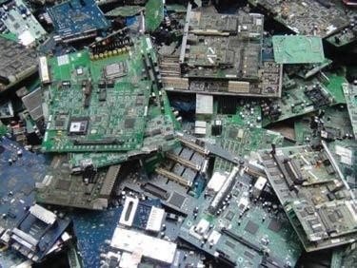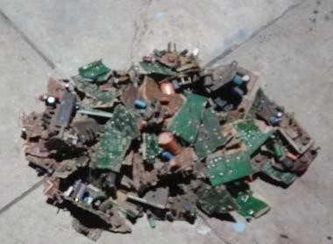

The E-waste that generated is usually disposed in the form of land fill, incineration, reuse, recycling. However, the cost of these disposal measures is high and has hazardous effect on our environment. It is necessary to arrive at a cost effective and environmental friendly recycling process, which may be considered as the real need hours…

CONCRETE is the second most essential material consumed after water. For many years, efforts have been made to use industrial by-products such as fly ash, silica fume, ground granulated blast furnace slag, etc. as admixtures in concrete constructions. The extraction of natural resources for construction materials creates environmental problems, and therefore, attention is being focused on the environment and safeguarding of natural resources and

recycling of waste Materials.

Gaps in the current scenario:

* Shortage of river sand,
* Skyrocketing cost of construction materials,
* Increasing environmental concern, and
* Adaptation of unscrupulous practices.

Therefore, a substitute is required with Similar grain size,

* Similar mechanical properties,
* Workable,
* Cost-effective, and
* No effect on cement chemistry.

Electronic waste (E-Waste) is one of the new waste materials that are emerging in the concrete industry. Disposal of large amounts of E-Waste material can be reused in the concrete industry where it also solves the disposal problem. Hence, the recycling and reusing of E-Waste in the concrete industry is considered as the most feasible application. E- Waste is a serious pollution problem for humans and also the environment. Therefore, some options are needed to be considered, especially on recycling material units. E- Waste is a loosely discarded surplus, broken, electrical or electronic devices. Rapid technology change and low initial cost have resulted in a fast growing surplus of E-Waste around the globe. Several tonnes of E-Waste need to be disposed per year. E-Waste contains numerous types of substances and chemicals creating serious human health and environment problems if not handled properly. Fig. 1 shows a view of E- Waste disposal.

## OBJECTIVES

* + To understand the suitable of E- waste as a replacement for coarse aggregate
  + To calculate the strength of concrete by partially replacement the coarse aggregates with 25 mm pieces of e waste
  + To find out the use of disposal e waste as construction material as coarse aggregate in concrete
  + To reduce the amount of toxic substance produced by certain waste electronic product
  + To develop and improve the technology for e waste management

### SCOPE OF THE PROJECT

* + Aggregate content is minimized by partial replacement with E-waste
  + To utilize the waste and locally available material
  + To produce less weight concrete with good compressive strength

### USES OF E- WASTE

* + - It protects the environment recycling e- waste can keep a range of harmful material out of the environment
    - It reduces business costs
    - It supports non- renewable recycling
    - It shows your eco-friendly credentials
    - Its super easy to recycle e-waste
    - Physical properties
    - Workability properties
    - Strength properties

## LITERATURE REVIEW

**Lakshmi and Nagan (2011)** studied the utilization of E-waste particles as coarse aggregates in concrete with a percentage replacement ranging from 0 % to 30% on the strength criteria of M20 concrete. The compressive strength, tensile strength and flexural strength of concrete with and without E-waste as aggregates was observed which exhibits a good strength gain.

**Arora and Dave (2013)** used E-waste and plastic waste in concrete. The grinded E-waste and plastic waste were replaced by 0%, 2%, and 4% of the fine aggregates. The compressive strength and flexural strength were tested and compared with control concrete. They found that compressive strength of concrete has increased by 5% and reduce the cost of concrete production by 7% at optimum percentage of grinded waste.

**Prasanna et al. (2014)** studied the non-recycling waste materials. They used E- waste materials as coarse aggregates replacement in concrete with a percentage from 0%, 5%, 10%, 15%, and 20% for M-30 grade concrete without using E-waste aggregates. They found that use of E-waste aggregates produces the lighter concrete as compared to conventional concrete.

**Manjunath (2015)** studied the utilization of E-waste particle as a fine and coarse aggregate in concrete. An experimental study was made on the use of E-waste particles as fine and coarse aggregates in concrete with a percentage replacement ranging from 0% to 30% (in an interval of 10%) for M20 grade of concrete. The compressive strength, tensile strength and flexural strength of concrete with E- waste gives better strength as compared to concrete without E-waste.

**Siddhique et al. (2015)** gave an overview on the use of E-waste as a substitute/replacement of aggregate in concrete. The effect of E-waste on the properties of concrete such as compressive strength, split tensile strength and durability were presented.

**Dawande et al. (2016)** studied the use of recycled E-waste material as a replacement of coarse aggregates in concrete. It was found that the use of E-waste aggregates results in the formation of light weight concrete. In this study coarse aggregate was partially replaced by E-waste material up-to 25% along with fly ash partially replacing cement in M40 grade of concrete and properties like workability, compressive strength and flexural strength were evaluated.

**Kale et al. (2015)** carried out the experimental study on E-waste as a replacement to fine aggregates in concrete. They found that compressive strength and split tensile strength of concrete pertaining to E-Waste aggregate is slightly lesser in comparison with control concrete mix.

**Donadkar et al. (2016)** presented an overview on possible use of E-waste like printed circuit board in concrete. It showed that E-waste can be a substitute for fine aggregate. More use of this tends to decreases the use natural aggregates in concrete and it is of prime importance that substitute of fine aggregate explored. **Suchithra et al. (2015)** studied the use of E-waste product as an alternative material for coarse aggregate for M20 grade mix. The coarse aggregate replaced in the range of 0%, 5%, 10%, 15%, and 20%. The mechanical and durability of the concrete mix was compared with control concrete mix. The test results showed that a satisfactory rise in compressive strength of E-waste concrete compared to conventional concrete and can be used in concrete effectively.

**Devi et al. (2017)** carried out the utilization of E-waste materials from discarded old computers, TVs, refrigerators, radios. The E-waste were used a partial replacement of the coarse aggregates, ranging from 0 % to 20%, for M20 concrete. They found that E-waste used as coarse aggregates exhibits strength gain.

**Raut et al. (2018)** studied the mechanical property of concrete like workability, compressive strength and flexural strength for M20 grade mix with 0.5 w/c ratio. They replaced coarse aggregate by 0 to 15% with regular interval of 5% with E- plastic aggregate.

In the present scenario, the problem disposing the E-waste can be reduced by utilizing it as replacement to construction materials. The objectives of the present study are, (i) to investigate the influence of the presence of E- waste as a partial replacement of coarse aggregate in concrete mixture, (ii) to carry out the mix design of M20 grade of concrete for normal mix (without e-waste) and with a partial replacement of coarse aggregates with E-waste material 5%, 10%, 15%, 20%, 25% and 30%, (iii) to study the effect of E-waste particle size using less than 10 mm, between 10 to 15 mm and up to 20 mm on compressive strength and flexural strength of concrete.

## METHODOLOGY

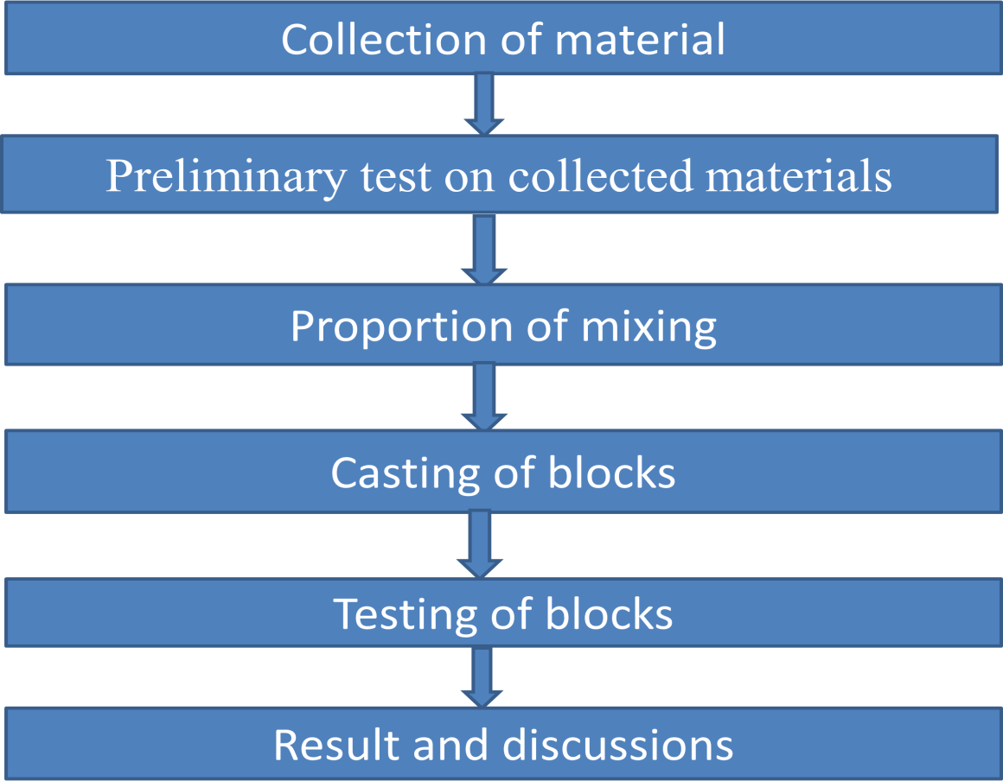

**Los Angeles abrasion value test of aggregates procedure**

* + - * Select the grading to be used in the test. It should be chosen such that it conforms to the grading to be used in construction, to the maximum extent possible.
      * Take 5 kg of sample for gradings A, B, C or D and 10 kg for gradings E, F anG.
      * Choose the abrasive charge as per.
      * Open the cover and feed the aggregates and steel balls in the cylinder. Replace the cover tightly.
      * Rotate the machine at a uniform speed of 30 to 33 revolutions per minute (rpm).
      * Allow the machine to run for 500 revolutions for gradings A,B, C or D and 1000 revolutions for grading E, F or G
      * Stop the machine after desired number of revolutions.
      * Remove the dust cover and take out materials.
      * Separate the steel balls and sieve the material on 1.70 mm IS sieve.
      * Wash the material coarser than 1.70 mm size.
      * Dry it in the oven to a constant weight and weigh to an accuracy of 1 g.
      * Calculate the percentage loss of material.
      * Take another sample and repeat the experiment. Find the mean of two values and report it as Los Angeles Abrasion value.

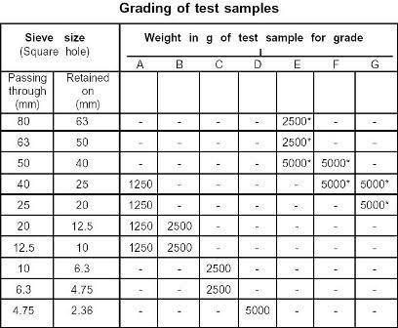

### Selection of Abrasive Carge

|  |  |  |
| --- | --- | --- |
| Grading | No. of steel balls | Weight of charge, g |
| A B C D E  F G | 12  11  8  6  12  12  12 | 5000 ± 25  4584 ± 25  3330 ± 20  2500 ± 15  5000 ± 25  5000 ± 25  5000 ± 25 |

**Record of observations:**

|  |  |  |
| --- | --- | --- |
| Grading selected: | Sample I | Sample II |
| Original weight of the sample, W1 (g.) |  |  |
| Weight of aggregates retained on 1.70 mm IS  sieve, W2 (g.) |  |  |
| Loss of weight, (W1 - W2) |  |  |
| Abrasion value ,(W1 – W2 ) / W1 X 100 |  |  |

Mean =

Los Angeles Abrasion Value

=

**Results:** The mean of the two results to the nearest whole number is reported as the “*Los Angeles Abrasion value*” of the material.

**Procedure:**

## Aggregate impact value test.

*The test sample*: It consists of aggregates sized 10 mm to 12.5 mm.

The aggregates should be dried by heating at 100°C-110°C for a periods of 4 hours and cooled.

* Sieve the material through 12.5 mm and 10 mm IS sieves. The aggregates passing through 12.5 mm sieve and retained on 10 mm sieve comprises the test materials.
* Pour the aggregates to fill about just 1/3rd depth of measuring cylinder.
* Compact the material by giving 25 gentle blows with the rounded end of the tamping rod.
* Add two more layers in similar manner, so that cylinder is full.
* Strike off the surplus aggregates.
* Determine the net weight of the aggregates to the nearest gram (W1).
* Bring the impact machine to rest without wedging or packing upon the level plate, block or floor, so that it is rigid and the hammer guide columns are vertical.
* Fix the cup firmly in position on the base of machine and place whole of the test sample in it and compact by giving 25 gentle strokes with tamping rod.
* Raise the hammer until its lower face is 380 mm above the surface of the aggregate sample in the cup and allow it to fall freely on the aggregate sample. Give 15 such blows at an interval of not less than one second between successive falls.
* Remove the crushed aggregates from the cup and sieve it through 2.36 mm IS sieve and weight the fraction retained in the sieve.

### Record of Observations:

|  |  |  |
| --- | --- | --- |
|  | Sample I | Sample II |
| Total weight of dry sample  taken, W1 (gm.) |  |  |
| Weight of portion passing  2.36 mm sieve, W2 (gm.) |  |  |
| Aggregate impact value,  (W2/W1)*100 |  |  |

Aggregate impact mean value =

**Results:** The mean of the two results to the nearest whole number is reported as the “*Aggregate Impact value*” of the material.

## SPECIFIC GRAVITY AND WATER ABSORPTION FOR COARSE AGGREGATES

### Procedure

* About 2 kg of aggregate sample is taken, washed to remove fines and then placed in the wire basket. The wire basket is then immersed in water, which is at a temperature of 220 C to 320 C.
* Immediately after immersion the entrapped air is removed from the sample by lifting the basket 25 mm above the base of the tank and allowing it to drop, 25 times at a rate of about one drop per second.
* The basket, with aggregate are kept completely immersed in water for a period of 24 ±

0.5 hour.

* The basket and aggregate are weighed while suspended in water, which is at a temperature of 220 C to 320 C.
* The basket and aggregates are removed from water and dried with dry absorbent cloth.
* The empty basket is suspended back in water tank and weighed.
* The surface dried aggregates are also weighed.
* The aggregate is placed in a shallow tray and heated to about 110 0C in the oven for 24 hours. Later, it is cooled in an airtight container and weighed.

## Procedure for specific gravity determination of aggregate finer than 6.3 mm :

* + A clean, dry Pycnometer is taken and its empty weight is determined.
  + About 1000g of clean sample is taken into the Pycnometer, and it is weighed.
  + Water at 27 0C is filled up in the Pycnometer with aggregate sample, to just immerse sample.
  + Immediately after immersion the entrapped air is removed from the sample by shaking Pycnometer, placing a finger on the hole at the top of the sealed Pycnometer.
  + Now the Pycnometer is completely filled up with water till the hole at the top, and after confirming that there is no more entrapped air in it, it is weighed.
  + The contents of the pycnometer are discharged, and it is cleaned.
  + Water is filled up to the top of the pycnometer, without any entrapped air. It is then weighed.

### Record of Observations:

1. Aggregate coarser than 6.3 mm:

|  |  |  |
| --- | --- | --- |
| **SL.**  **NO**. | **DETAIL S** | **OBSERVE**  **D VALUES** |
| 1. | Weight of saturated aggregate and basket in water, W1 (gm.) |  |
| 2. | Weight of basket in water, W2 (gm.) |  |
| 3. | Weight of saturated aggregate in air, W3 (gm.) |  |
| 4. | Weight of oven dry aggregate, W4 (gm.) |  |
| 5. | Apparent specific gravity: W4/[W4-(W1-W2)] |  |
| 6. | Bulk specific gravity: W4/[W3-(W1-W2)] |  |
| 7. | Water absorption: [(W3- W4)x 100]/ W4 |  |

### RESULT

Bulk specific gravity = Apparent specific gravity =

Water adsorption = %